LECTURE/ TUTORIAL 5, 6 , 7--Examples of present worth methods
Example-1ple -1
There are two alternative small water resources projects. Both the alternatives have
same useful life. The cash flow details of alternatives are as follows;

Alternative-1: Initial purchase cost = Rs.3,00,000, Annual operating and maintenance
cost = Rs.20,000, Expected salvage value = Rs.1,25,000, Useful life = 5 years.
Alternative-2: Initial purchase cost = Rs.2,00,000, Annual operating and maintenance
cost = Rs.35,000, Expected salvage value = Rs.70,000, Useful life = 5 years.
Using present worth method, find out which alternative should be selected, if the rate of
interest is 10% per year.
Solution:
Since both alternatives have the same life span i.e. 5years, the present worth of the
alternatives will be compared over a period of 5 years.
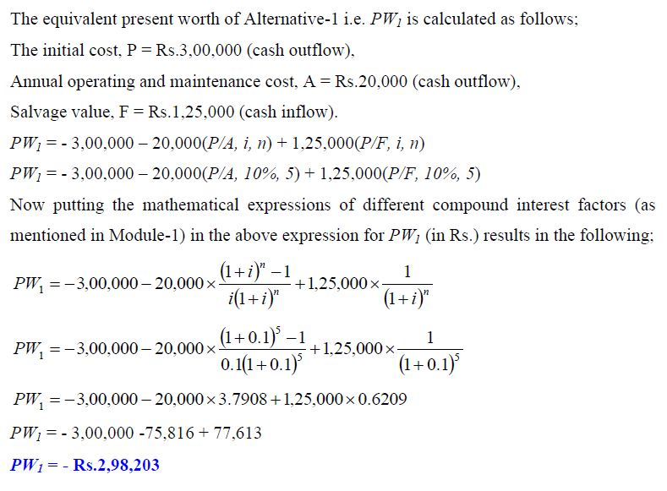

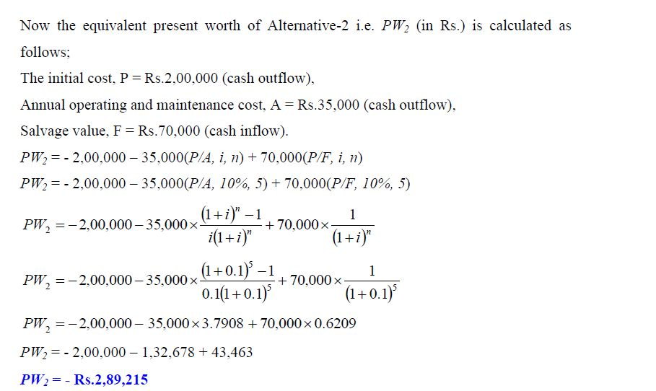
Comparing the equivalent present worth of both the alternatives, it is observed that
Alternative-2 will be selected as it shows lower negative equivalent present worth
compared to Alternative-1 at the interest rate of 10% per year.

EXAMPLE--2EEE
-2
Alternative-1: Initial purchase cost = Rs.300000, Annual operating and maintenance cost
= Rs.20000, Expected salvage value = Rs.125000, Useful life = 5 years.

Alternative-2: Initial purchase cost = Rs.200000, Annual operating and maintenance cost
= Rs.35000, Expected salvage value = Rs.70000, Useful life = 5 years.

The annual revenue to be generated from production of crops (by irrigation)
from Alternative-1 and Alternative-2 are Rs.50000 and Rs.45000 respectively. Compute
the equivalent present worth of the alternatives at the same rate of interest as in Example-
1 i.e. 10% per year and find out the economical alternative.
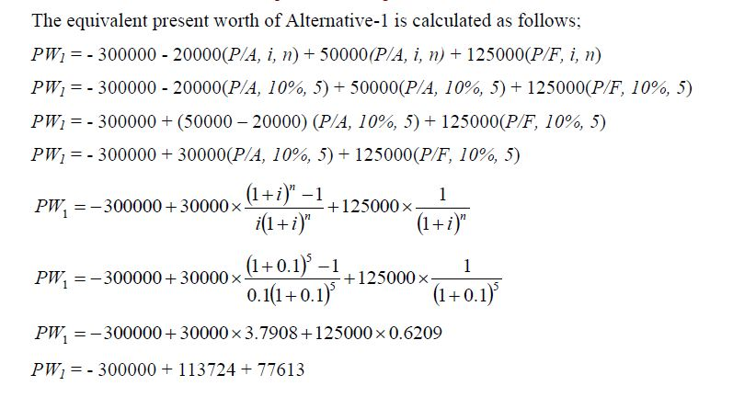
PW₁ ₌ 108663

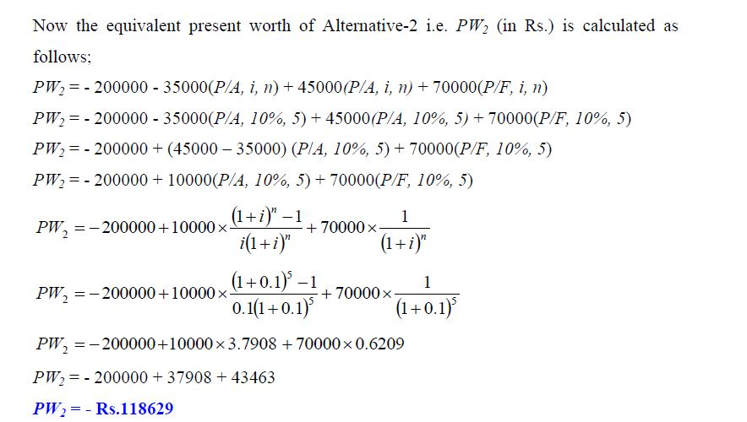

As per rules, the alternative 2 has the largest present worth and should be chosen.

EXAMPLE--3

A construction contractor has three options to purchase a dump truck for transportation
and dumping of soil at a construction site. All the alternatives have the same useful life.
The cash flow details of all the alternatives are provided as follows;

Option-1: Initial purchase price = Rs.2500000, Annual operating cost Rs.45000 at the
end of 1st year and increasing by Rs.3000 in the subsequent years till the end of useful
life, Annual income = Rs.120000, Salvage value = Rs.550000, Useful life = 10 years.
Option-2: Initial purchase price = Rs.3000000, Annual operating cost = Rs.30000,
Annual income Rs.150000 for first three years and increasing by Rs.5000 in the
subsequent years till the end of useful life, Salvage value = Rs.800000, Useful life = 10
years.
Option-3: Initial purchase price = Rs.2700000, Annual operating cost Rs.35000 for first
5 years and increasing by Rs.2000 in the successive years till the end of useful life,
Annual income = Rs.140000, Expected salvage value = Rs.650000, Useful life = 10
years.
Using present worth method, find out which alternative should be selected, if the rate of interest is 8% per year.

SOLUTION :

For Option-1, the annual operating cost is in the form of a positive uniform gradient
series with gradient starting from end of year „2‟. The operating cost at the end of
different years can be split into the uniform base amount of Rs.45000 and the gradient
amount in multiples of Rs.3000

The present worth of the uniform gradient series will be located at the beginning i.e. in
year „0‟ i.e. 2 years before the commencement of the uniform gradient.

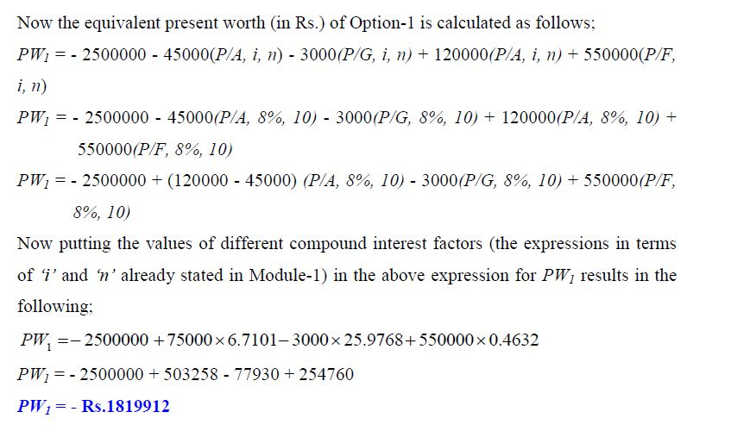
For Option-2, the annual income is in the form of a positive uniform gradient series with
gradient starting from end of year „4‟. The annual income can be split into the uniform
base amount of Rs.150000 and the gradient amount in multiples of Rs.5000 starting from
end of year „4‟

The equivalent present worth of the gradient series (of the annual income) starting from
end of year „4‟ will be located at the end of year „2‟ i.e. 2 years before the start of the
gradient. Further the present worth of this amount at beginning i.e. at time „0‟ will be
obtained by multiplying the equivalent present worth „Pg’ (shown in Fig. 2.8) at the end
of year „2‟ (which is a future amount) with the single payment present worth factor (P/F,
i, n).

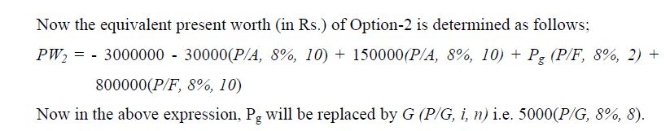
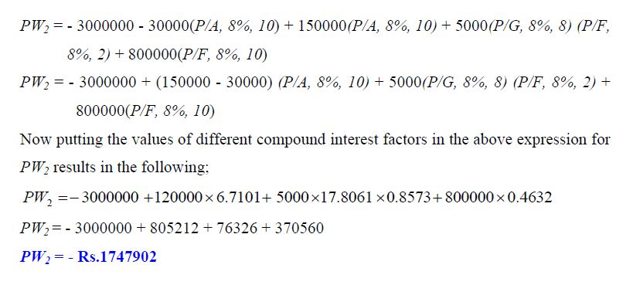

For Option-3, the annual operating cost is in the form of a positive uniform gradient
series with gradient starting from end of year „6‟. The annual operating cost can thus be
split into the uniform base amount of Rs.35000 and the gradient amount in multiples of
Rs.2000 starting from end of year „6‟
The equivalent present worth of the gradient series for the annual operating cost starting
from end of year „6‟ will be located at the end of year „4‟. Further the present worth of
this amount at time „0‟ will be determined by multiplying the equivalent present worth
„Pg’ (shown in Fig. 2.10) at the end of year „4‟ with the single payment present worth
factor (P/F, i, n).

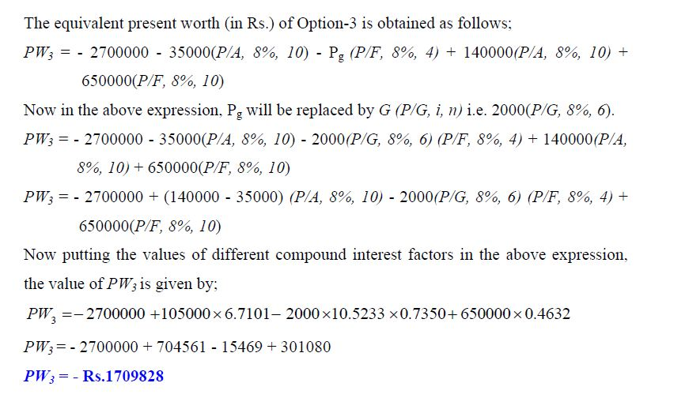

From the comparison of equivalent present worth of all the three mutually exclusive
alternatives, it is observed that Option-3 shows lowest negative equivalent present worth
as compared to other options. Thus Option-3 will be selected for the purchase of the
dump truck

